Week 6 Penetration Testing Report

Introduction

This report document hereby describes the proceedings and results of a Black Box security assessment conducted against the Week 6 Labs. The report hereby lists the findings and corresponding best practice mitigation actions and recommendations.

1. Objective

The objective of the assessment was to uncover vulnerabilities in the Week 6 Labs and provide a final security assessment report comprising vulnerabilities, remediation strategy and recommendation guidelines to help mitigate the identified vulnerabilities and risks during the activity.

2. Scope

This section defines the scope and boundaries of the project.
Application Name | {Cross-Site Request Forgery}

3. Summary

Outlined is a Black Box Application Security assessment for the Week 6 Labs.

Total number of Sub-labs: 6 Sub-labs

High | Medium | Low
2 | 2 | 2

High - Number of Sub-labs with hard difficulty level
Medium - Number of Sub-labs with Medium difficulty level
Low - Number of Sub-labs with Easy difficulty level

1. {Cross-Site Request Forgery}

1.1. {Easy CSRF}

Reference | Risk Rating
Easy CSRF | Low
Tools Used
Google Chrome, CSRF tool, Burp Suite
Vulnerability Description
I found this vulnerability by intercepting a password changing request through an attacker account and forged it to get access to the victims account. Then I send this request to the victim and when the victim opens and clicks on the request, the password will change successfully and will get access to the victim's account.
How It Was Discovered
Automated Tools and Manual Analysis
Vulnerable URLs
https://www.bugbountyhunter.org/internship_labs/HTML/csrf_lab/lab_1/passwordChange.php
Consequences of not Fixing the Issue
Attacker causes the victim user to carry out unintentional actions like taking over users accounts illegally. Compromising privileges role within the application, and taking over applications data and functions.
Suggested Countermeasures
Anti CSRF tokens, different for different users, and Same site cookies.
References
https://owasp.org/www-community/attacks/csrf

Proof of Concept

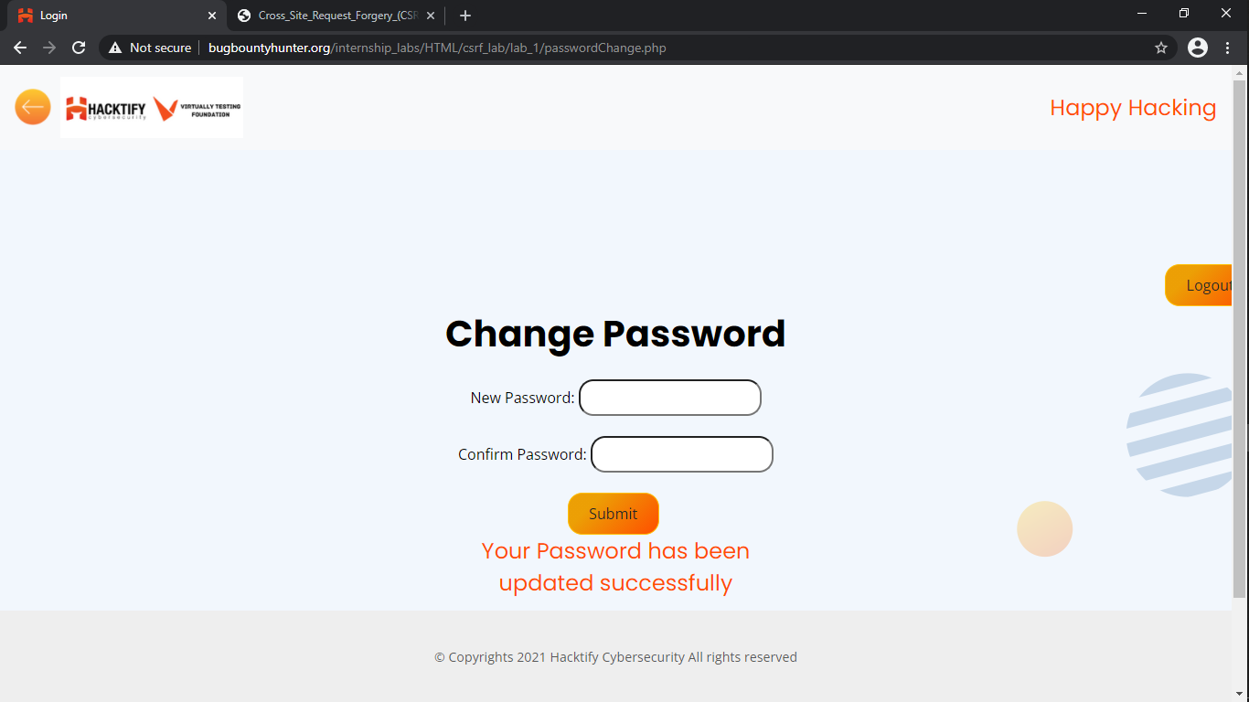

1.2. {Always Validate Tokens}

Reference | Risk Rating
Always Validate Tokens | Medium
Tools Used
Google Chrome, CSRF tool, Burp Suite
Vulnerability Description
I found this vulnerability by intercepting a password changing request through an attacker account and forged it to get access to the victims account. Then I send this request to the victim and when the victim opens and clicks on the request, the password will change successfully and will get access to the victim's account.
How It Was Discovered
Automated Tools and Manual Analysis
Vulnerable URLs
https://www.bugbountyhunter.org/internship_labs/HTML/csrf_lab/lab_2/passwordChange.php
Consequences of not Fixing the Issue
Attacker causes the victim user to carry out unintentional actions like taking over users accounts illegally. Compromising privileges role within the application, and taking over applications data and functions.
Suggested Countermeasures
Anti CSRF tokens, different for different users, and Same site cookies.
References
https://www.acunetix.com/websitesecurity/csrf-attacks/

Proof of Concept

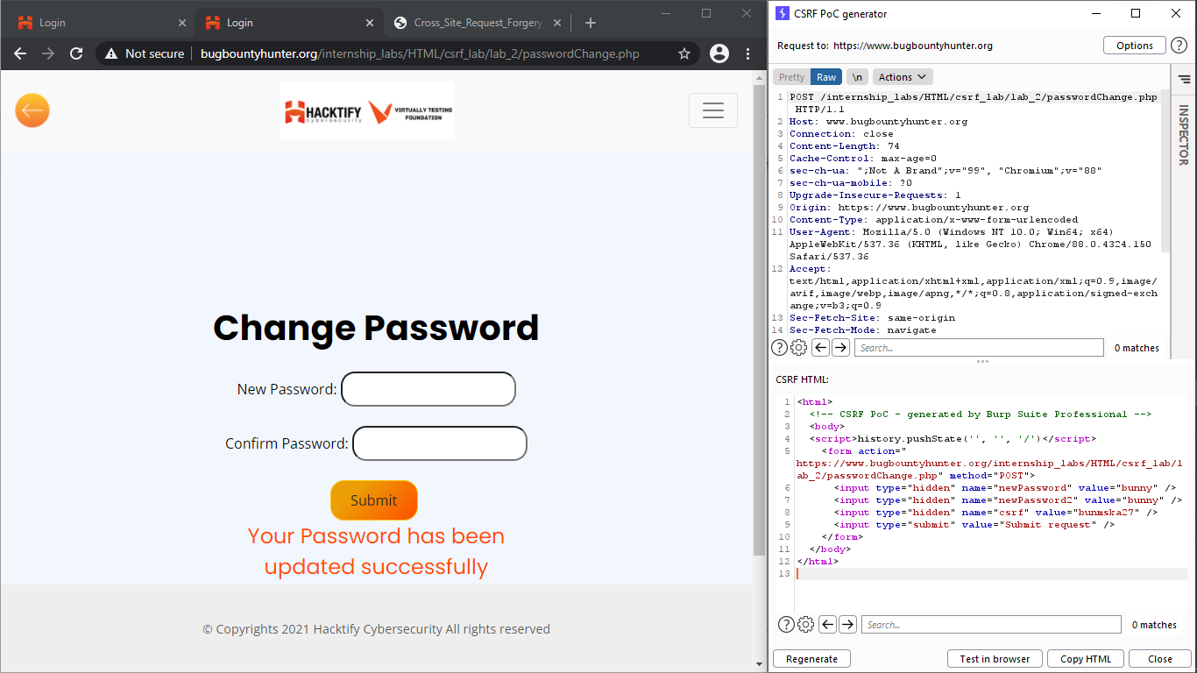

1.3. {I Hate When Someone Uses My Tokens!}

Reference | Risk Rating
I Hate When Someone Uses My Tokens! | Medium
Tools Used
Google Chrome, CSRF tool, Burp Suite
Vulnerability Description
I found this vulnerability by intercepting a password changing request through an attacker account and forged it to get access to the victims account. Then I send this request to the victim and when the victim opens and clicks on the request, the password will change successfully and will get access to the victim's account.
How It Was Discovered
Automated Tools and Manual Analysis
Vulnerable URLs
https://www.bugbountyhunter.org/internship_labs/HTML/csrf_lab/lab_4/passwordChange.php
Consequences of not Fixing the Issue
Attacker causes the victim user to carry out unintentional actions like taking over users accounts illegally. Compromising privileges role within the application, and taking over applications data and functions.
Suggested Countermeasures
Anti CSRF tokens, different for different users, and Same site cookies.
References
https://portswigger.net/web-security/csrf

Proof of Concept
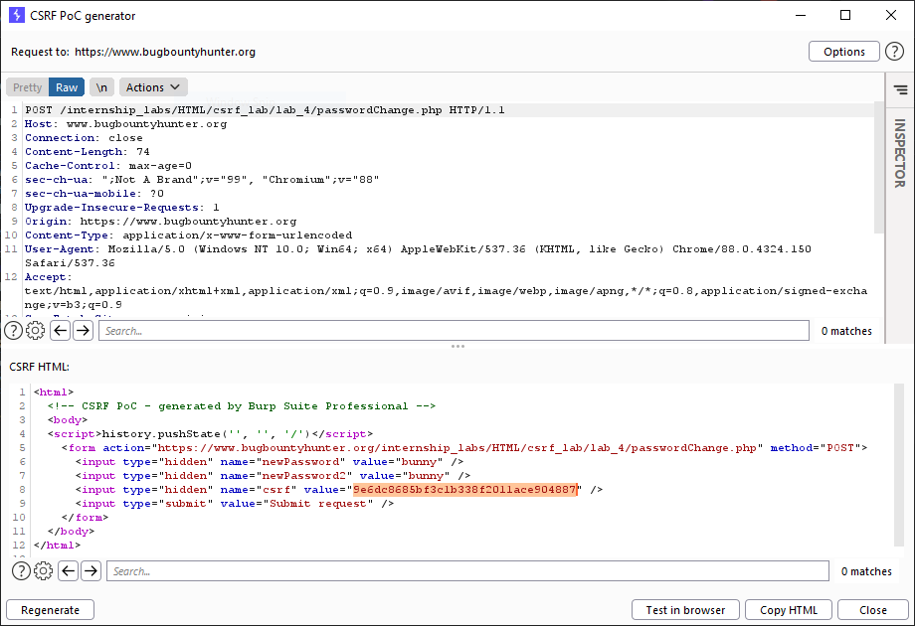

1.4. {GET Me or POST ME}

Reference | Risk Rating
GET Me or POST ME | Low
Tools Used
Google Chrome, CSRF tool, Burp Suite
Vulnerability Description
I found this vulnerability by intercepting a password changing request through an attacker account and forged it to get access to the victims account, also changed the request method from POST to GET. Then I send this request to the victim and when the victim opens and clicks on the request, the password will change successfully and will get access to the victim's account.
How It Was Discovered
Automated Tools and Manual Analysis
Vulnerable URLs
https://www.bugbountyhunter.org/internship_labs/HTML/csrf_lab/lab_6/passwordChange.php?newPassword=bunny&newPassword2=bunny&csrf=9f30abfb7a0141bb657fa6d587a5878b
Consequences of not Fixing the Issue
Attacker causes the victim user to carry out unintentional actions like taking over users accounts illegally. Compromising privileges role within the application, and taking over applications data and functions.
Suggested Countermeasures
Anti CSRF tokens, different for different users, and Same site cookies.
References
https://owasp.org/www-community/attacks/csrf

Proof of Concept

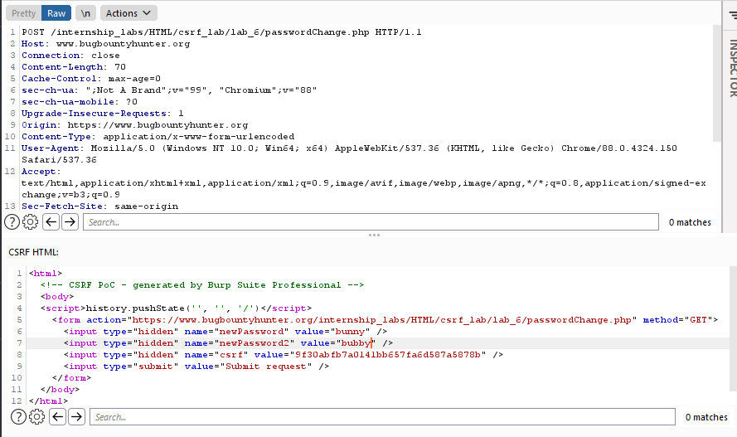

1.5. {XSS is Saviour}

Reference | Risk Rating
XSS is Saviour | Hard
Tools Used
Google Chrome, CSRF tool, Burp Suite
Vulnerability Description
I found this vulnerability by intercepting a password changing request through an attacker account and forged it to get access to the victims account, by applying XSS payloads onto it. Then I send this request to the victim and when the victim opens and clicks on the request, the password will change successfully and will get access to the victim's account.
How It Was Discovered
Automated Tools and Manual Analysis
Vulnerable URLs
https://www.bugbountyhunter.org/internship_labs/HTML/csrf_lab/lab_7/lab_7.php?name=%3Cscript%3Ealert%28document.cookie%29%3C%2Fscript%3E&show=Save
Consequences of not Fixing the Issue
Attacker causes the victim user to carry out unintentional actions like taking over users accounts illegally. Compromising privileges role within the application, and taking over applications data and functions.
Suggested Countermeasures
Anti CSRF tokens, different for different users, and Same site cookies.
References
https://www.acunetix.com/websitesecurity/csrf-attacks/

Proof of Concept

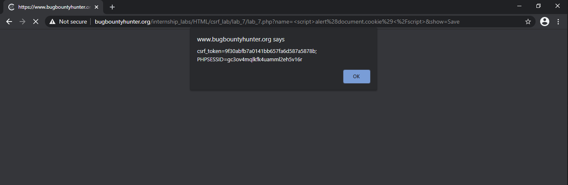

1.6. {Rm - Rf Token}

Reference | Risk Rating
Rm - Rf Token | Hard
Tools Used
Google Chrome, CSRF tool, Burp Suite
Vulnerability Description
I found this vulnerability by intercepting a password changing request through an attacker account and forged it to get access to the victims account. Then I send this request to the victim and when the victim opens and clicks on the request, the password will change successfully and will get access to the victim's account.
How It Was Discovered
Automated Tools and Manual Analysis
Vulnerable URLs
https://www.bugbountyhunter.org/internship_labs/HTML/csrf_lab/lab_8/passwordChange.php?newPassword=bunny&newPassword2=bunny&csrf=9f30abfb7a0141bb657fa6d587a5878b
Consequences of not Fixing the Issue
Attacker causes the victim user to carry out unintentional actions like taking over users accounts illegally. Compromising privileges role within the application, and taking over applications data and functions.
Suggested Countermeasures
Anti CSRF tokens, different for different users, and Same site cookies.
References
https://portswigger.net/web-security/csrf

Proof of Concept

